21.4: Mass of gold = 17.7 g and the atomic weight of gold is 197 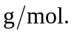 So the number of atoms
a) 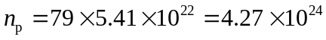
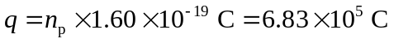
b) 